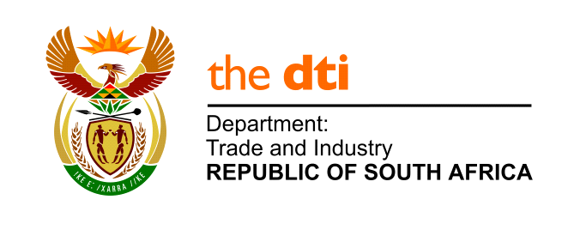

TRADE ENQUIRY FORM
Date Received |  | Date Completed
Allocated to | Dept. Trade and Industry RSA | Reference Number

FOREIGN OFFICE
Office Contact Details and Contact Person: Liaison Office of South Africa
Cont.per : Ms. Sibongile Mabasa/ Ms. Cissy Chiu
Address : Suite 1301 13th Floor No.205 Dun Hwa North Road Taipei City Taiwan
Tel : +886 2 81758588
Fax : +886 2 27125109
Email : mabasam@dirco.gov.za / chiuc@dirco.gov.za

COMPANY CONTACT DETAILS
Company/Organisation Name:

Type of business (please tick one): | Manufacturer | Importer | Distributor | Wholesaler | Retailer | Agent | Other (please state):
Contact Person:
Address:

Telephone:
Facsimile:
E-Mail:
Website:

PRODUCT
Product Required:
Type (colour, size etc.):
Quality (grade, ISO etc.):
HS Code:

QUANTITY
Quantity Required (units, volume, container etc.):

DELIVERY
When is the product required:
How frequently is the product required:
Destination Port:

FOR FER USE:
How did you acquire this enquiry: (please tick one) | Face-to-face meeting | Email  **** | Telephone | Site Visit | Trade Show | Other (please state):

Further notes:

Please ensure that all the fields are filled in.
NB. The information in this form is shared with South African companies. Thank you

